Photosynthesis Notes

Photosynthesis is the process by which autotrophic organisms (producers, plants, etc) make their own sugars to use in cellular respiration. The sugar that is produced is glucose.

Organelle | Function | Molecules In | Molecules Out | Process
Chloroplasts, found in PLANT and autotrophic organisms (like Euglena and higher forms of algae) ONLY  On the exam, chloroplasts will appear only in plant cells and are just oval black spots | To make organic molecules (glucose/sugars) from inorganic molecules (water and carbon dioxide) | CO₂  H₂O  Energy (NOT a molecule) in the form of light from the sun  Chlorophyll found in the chloroplasts traps the light energy used for conversion | O₂  C₆H₁₂O₆ (glucose) | photosynthesis

Photosynthesis Formula:

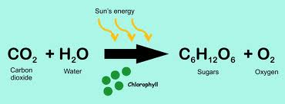

Photosynthesis Images:
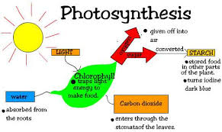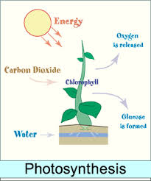
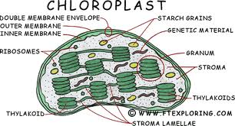

What can affect the rate of photosynthesis?

Temperature, amount of CO2, amount of water, amount of light, the type of light (color), pH, amount and type of soil, the size of the pot, etc…. EVERY limiting factor can affect the rate of photosynthesis in a plant and in turn affect plant growth (no food, no growth)

